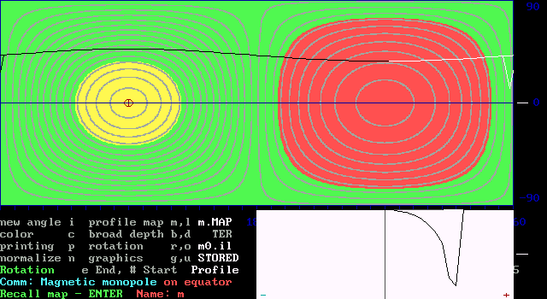

Magnetic monopole with coordinates  = 90°  = 0° r = 0.3.
The field is always positive with a minimum at  = 270°  = 0°,
corresponding to the phase curve of the integral longitudinal field.
The line profile is asymmetric and has its deepest point a the field
minimum by phase 0.75, which deviates from the gravity center.
The profile is moving on the screen in phase of the rotation.

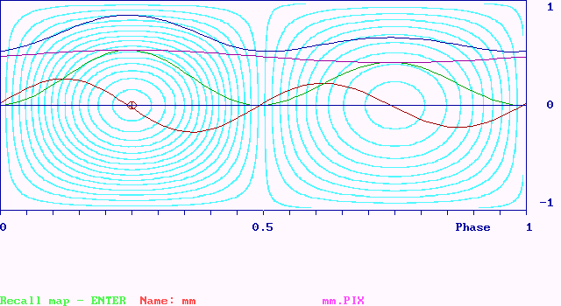

Phase curves of the Stokes parameters for a magnetic monopole:
I blue Q red U green V violet
The curves of the parameters I and V show a similar behavior because of the overall positive field strength in radial direction.
The Q-curve has positive and negative parts because of the gradient
of the field in direction of the longitude with maxima and minima and zero at the pole and counter pole. The U-curve is always positive.

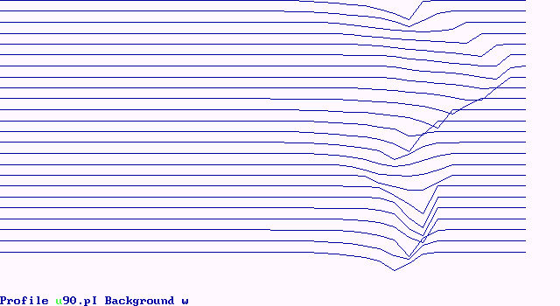

I

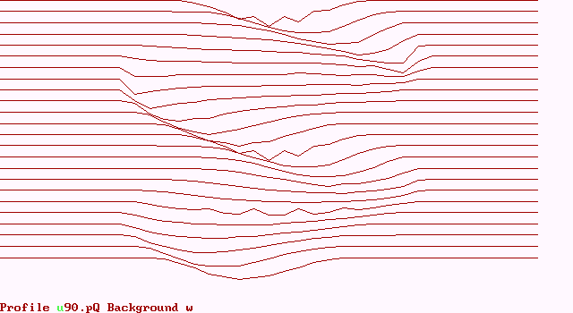

Q

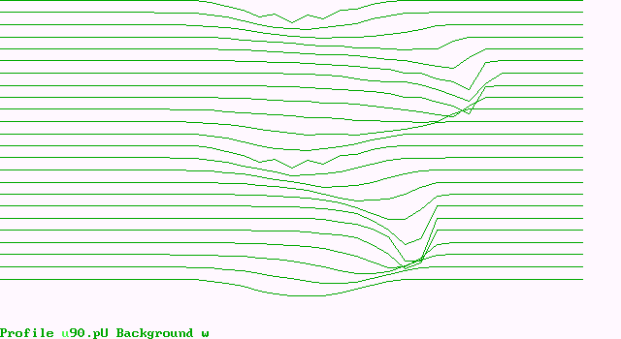

U

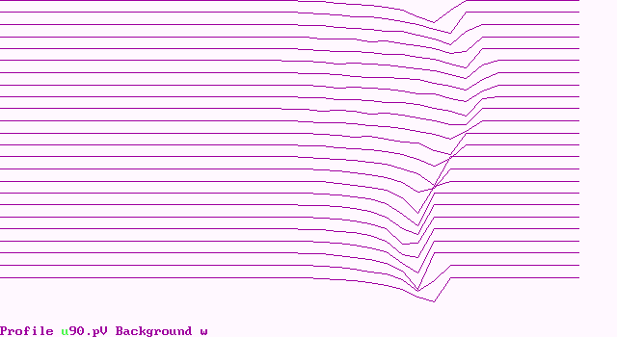

V

Series of line profiles by phase step 0.05 for Stokes I, Q, U, V .
A virtual magnetic monupole is investigated for its Stokes profiles.
The parameters I and V reflect best the expected course of the field;
Q shows a double wave with a change of polarity and asymmetry;
U is only positive; I, U an V have the steep edge at the positive side.

The deforming effect
of stellar magnetic fields on spectral line profiles
Ewald Gerth and Yurij V. Glagolevskij

The profile of a stellar spectral line is formed by the transfer of radiation through the atmosphere by atomic processes at differ-ent chemical elements distributed usually unequally over the surface of a star.
The theory of model atmospheres accounts for all possible physical conditions, but is worked out mainly for a homogene-ous element arrangement in a plane atmosphere stratification. This plane atmosphere line profile, however, is heavily deform-ed by the geometry of the topographic element distribution and the magnetic surface field structure as well as the projection to the line of sight of the radiation from all surface points of the star's sphere and its integration over the visible disk.
The line forming by the geometry of projection and element distribution is used for the inverse procedure of Doppler imaging by V.L. Khokhlova and her followers. We consider here only the influence of the magnetic field on the line profile including all Stokes-parameters I, Q, U, V , which we study in separation from other effects. The outcome is, that the magnetic field and the projection make a symmetric "plane atmosphere profile" asymmetric in dependence on the aspect of the star's globe in phase of rotation.
The line profile deformation by the magnetic field leads to a fatal consequence for the traditional measurement of stellar magnetic fields by the Zeeman displacement of the circularly polarized ↓-components: The large scatter of measuring points is partly due to the uncontrolled asymmetry of line profiles!

Some theses to theory and graphical representation:

The observation of the integral magnetic field from the star’s surface is given as phase curves and line profiles of the polariz-ed light according to the four Stokes parameters I, Q, U, V.

The MCD-method offers the possibility of analyzing the magnetic field in respect to its generating sources, separating even combinations of sources like magnetic dipoles.

With the help of the model, typical phase curves and line profiles can be constructed, compared with the observed ones, and fitted to them by variation of parameters.

Here are raised only two typical cases:
1. magnetic monopole
2. magnetic dipole,
both seen equator-on with the poles in the equatorial plane.

We demonstrate here only the very simple cases. The algorithm for the calculation of phase curves and line profiles from the magnetic field distribution an the star’s surface is, of course, much more general and allows arbitrary angles if sight and the overlay of an opacity layer on the surface by a factor. The line profiles with gravity center are shown on the screen, moving in the course of the rotation.

The theory for the algorithms of the computer program is described by Gerth et al. (2001, 2004). The program allows the calculation and the graphical representation of maps, globes and line profiles in connection with the phase relation.

The line profile is formed only by the weighted integration over the visible hemisphere of the field components on the surface elements in direction to the observer accounting for the limb darkening. The physical line forming is restricted to the geometrical influence. Other influences like radiative transfer and distribution of chemical elements are not accounted for.

The model calculations are very instructive, because by this way the clean and undisturbed situation is investigated, under which the magnetic field is generated out of its sources.

Results:
- The phase curves represent the course of integral
magnetic field, which is the gravity center of the profile.
- The line profiles are usually asymmetric and deviate heavily from the (Gauss-) normal distribution.
- Maximum and gravity center do not coincide.
- A maximum is not given by the sight pole-on, but by the integral over the disk of all field components in sight.
- The profiles vary in form and width with the phase.
- The stokes components Q and U produce double waves
of the phase curves and an inversion of the profile form.
- The I and V Stokes components show the best correla-tion of the profile to the phase curve.
- Superpsition of 2 monopole profiles yields dipole ones.

References:

Gerth E., Glagolevskij Yu.V.: 2001, in: Magnetic fields across the Hertz-sprung-Russell diagram, eds.: Mathys G., Solanki S.K., Wickramsinghe D.T., Santiago de Chile, 248, 333

Gerth E., Glagolevskij Yu.V.: 2004, in: Proc. International Meeting and Workshop 27.8.-2.9.2003, SAO Nizhnij Arkhyz, Russia. (in press)

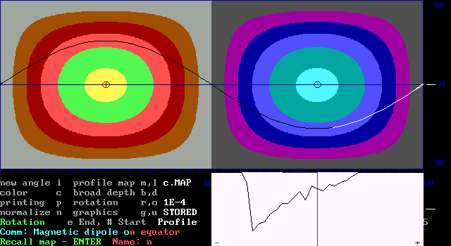

Central magnetic dipole with separated magnetic charges :

Parameters: Radius-fraction Longitude Latitude Charge
r₁ = 0.5 ₁ = 90° ₁ = 45° Q₁ = 1
r₂ = 0.5 ₂ = 270° ₂ = 45° Q₂ = 1
The line profile changes the polarity at phases 0 and 0.5 with a nearly rectangular form and shows at the poles an extreme asymmetry with a steep edge at the side turned away from the middle line.

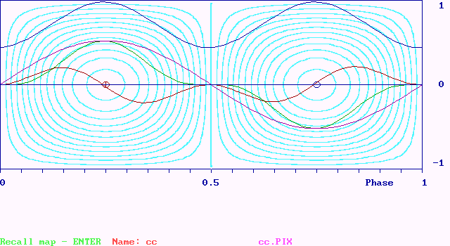

Phase curves of the Stokes parameters for a magnetic dipole I Q U V
The first part of the phase curves up to phase 0.5 shows principle agreement with the curves of the magnetic monopole. In the second part the polarity is changing. Nevertheless, extrema and zero points are similarly arranged. The U-curve is has its extrema at the poles, which coincide there with the V-curve.
All curves show rotational symmetry with turning point at zero.

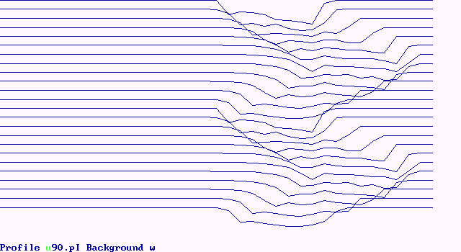

I

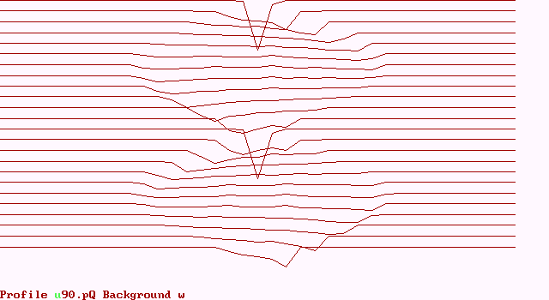

Q

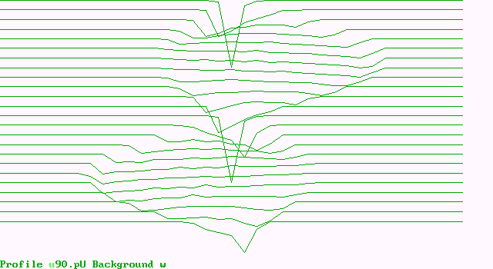

U

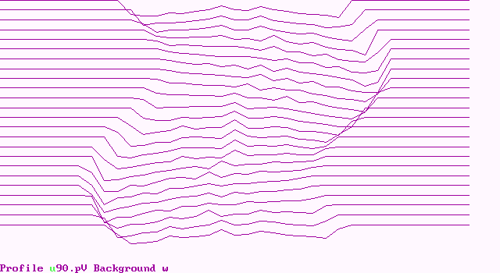

V

Series of line profiles by phase step 0.05 for Stokes I, Q, U, V .
Stokes profiles of a magnetic dipole consisting of two magnetic charges in the equatorial plane. The parameters I and V reflect also for a dipole best the expected course of the field. Besides the double wave, at Q and U the variability of the wave length is conspicuous.
with a change of polarity and asymmetry; U is only positive; I, U an V have the steep edge at the positive side.

